Name_________________ Summative Date: ____________
6th Grade Math
Statistics Summative Review
1) Tell whether the following questions are statistical (s) or non-statistical (n) questions.
a) How many sandwich shops are on SOM Center Road? _____________
b) What are the favorite movies of students in 6th period math? _____________
c) What are the weights of all students on the Dream team? _____________
d) Who are the guidance counselors at MMS? _____________

2) Circle the questions above that would have responses which are considered categorical data.

3) Find the mean, median, mode, and range of the following set of numbers:
24, 10, 25, 10, 33, 18

Mean: _______

Mode: _______

Median: _______

Range: _______

4) Mrs. Trentanelli gave four Social Studies tests this quarter. She accidently lost one of Kari’s tests. She knows that Kari had a mean score of 80 and received scores of 75, 85, and 90 on three of her tests. What is the missing test score? Show or explain how you found your answer.

Points Scored | Tally | Frequency
0 - 9
5) Divide the following data that represents the scoring by Cavs players in the last playoff game into 4 intervals.
2, 25, 7, 0, 14, 39, 8, 4, 17, 11, 32, 19, 4, 6,
33, 20, 5, 3,

Use the data above to create a histogram.

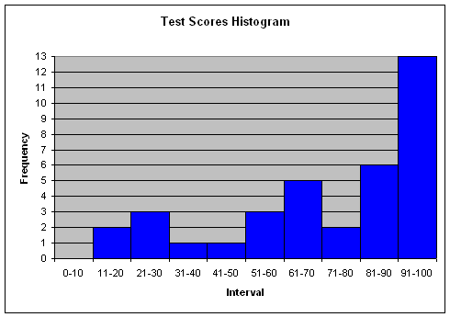
6) The histogram to the right shows the test scores from the last summative.

What cannot be determined by this data?
- The total number of test scores
- The highest test score
- Number of test scores 71 or higher
- Number of test scores 60 or lower

7) Create a line plot for the following data.
Number of Pets | Student Responses from 1st Period
0 | 3
1 | 6
2 | 9
3 | 5
4 | 2
5 | 1

_________________________________

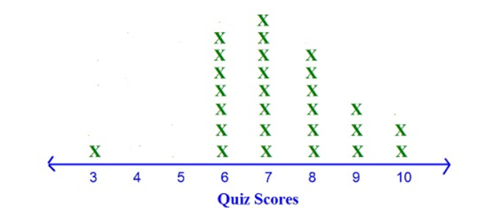
8) Using the line plot below, describe its distribution. You must use at least three of the following vocabulary words in your description: cluster, gap, outlier, mean, median, mode, and range.

_______________________________________________________________________________
_______________________________________________________________________________
_______________________________________________________________________________
_______________________________________________________________________________

9) The data below represents the amount of money spent by each student at the Cleveland Zoo gift shop. Use this data to create a box-and-whisker plot.
2, 25, 7, 5, 14, 39, 8, 38, 17, 11, 32, 19, 4, 20, 5
________________________________________________________________________________
Five Number Summary
Minimum: _____
Lower Quartile: _____
Median: _____
Upper Quartile: _____
Maximum: _____

0 10 20 30 40

